Irish National Orthopaedic Register
Current Status (Feb 2020)
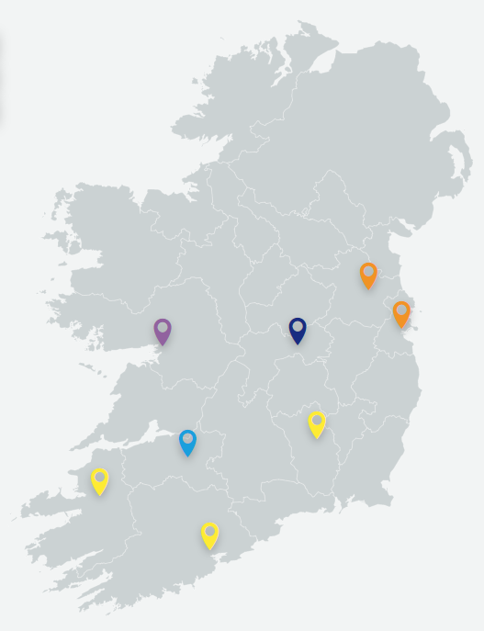 | 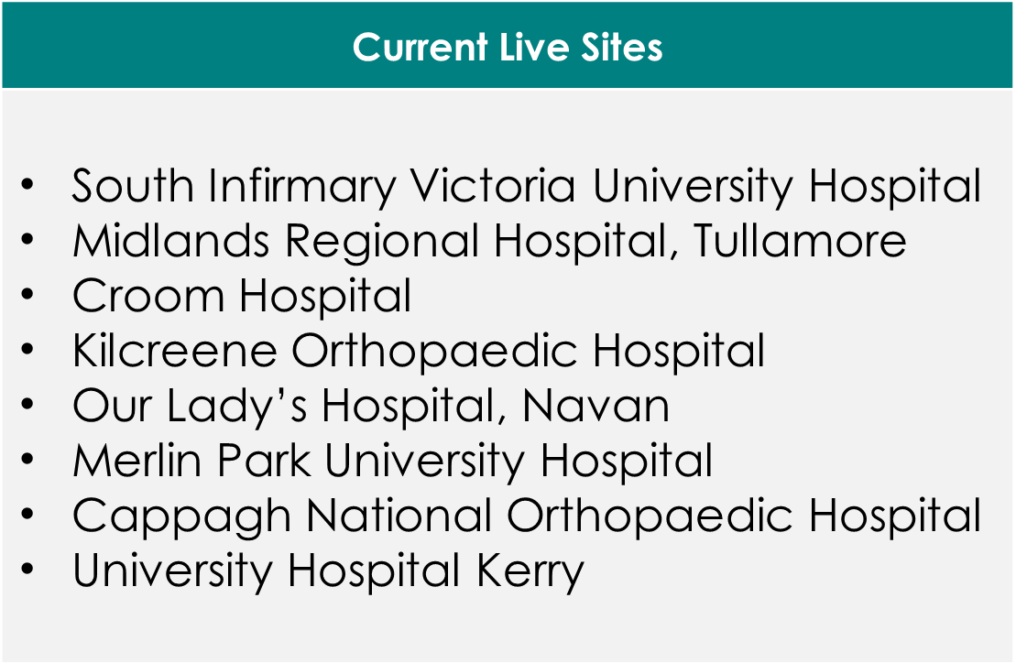

Plans for 2020
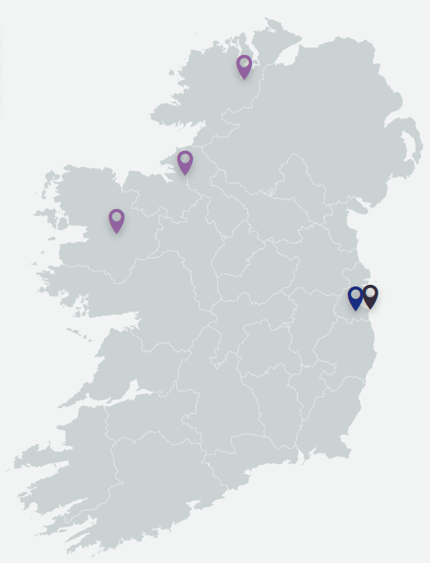 | 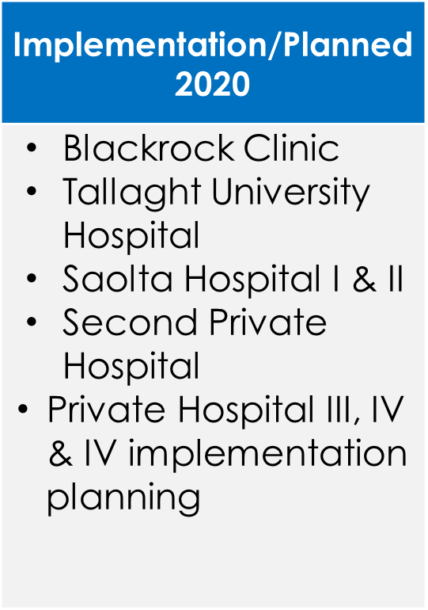

If you work in a Private Hospital and wish to become involved in INOR, please contact inor@noca.ie or 087 9781008

