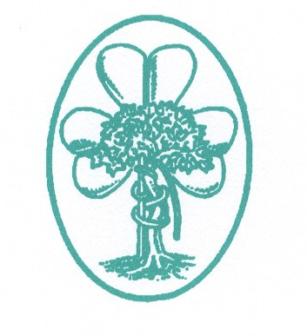
IRISH ORTHOPAEDIC ASSOCIATION
BASIC SCIENCE SESSION– FRIDAY 14TH JUNE 2019 2pm – 5.30pm

COURSE ORGANISER : MR KEITH SYNNOTT

Lectures

Basic science of arthroplasty ( viscoelastic properties of cement, material properties and wear)

Basic science of trauma (modes of fixation/locking plates/working length/fracture biology/healing&bone grafting)

Overview of study designs and principles

Design of an operating theatre

Free body diagrams and Newtonian orthopaedics

This will be followed by a series of mock vivas.

Examiners to be confirmed.

PLEASE REGISTER YOUR INTEREST FOR THIS SESSION VIA EMAIL WITH EMER AGNEW ON irishortho@gmail.com and give your current position including year on training scheme (if applicable) and current hospital.

